Lesson 19 Net Ninja react hooks Reducers

Reducers

<https://www.youtube.com/watch?v=uXWycyeTeCs&list=PL4cUxeGkcC9hNokByJilPg5g9m2APUePI&index=19>

Reducers are a pattern of coding which centralizes all of the methods for changing state into a single function. It is an approach similar with redux reducers

Currently Book Context has 2 functions 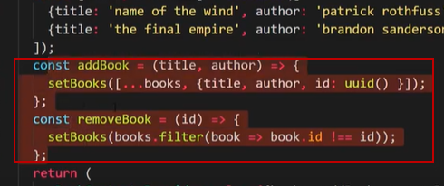

That interact with state, only 2 but big apps can have many .

Right now we have to pass all functions dealing with state into this value property in the context

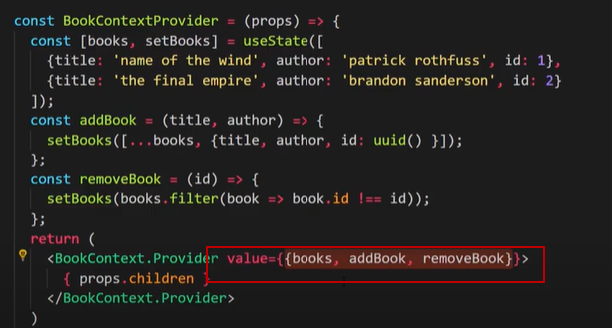

Then when consuming the context have to get all of the functions separately in our components that use them.

Instead what we could do is consolidate all the functions into one single reducer function that will make app easier to maintain in the long run .

This is just a coding pattern and you do not have to use it.

3 parts

1 Reducer Function - state manipulation logic interacts with state and changes the data – the reducer takes in an action and state

2 Action Object -describes the type change we want to make , can pass in a payload too

3 Dispatch – sends the action to the reducer using a dispatch function

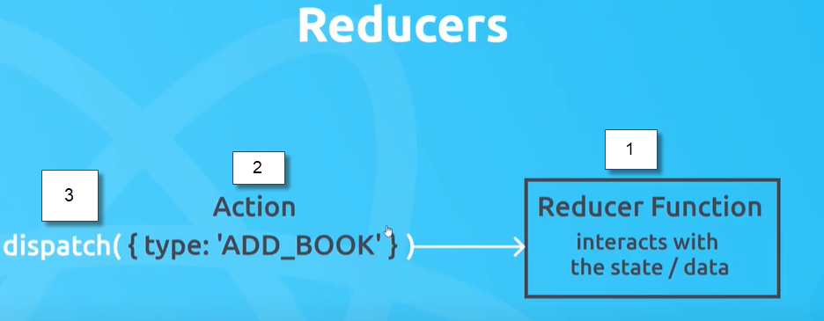

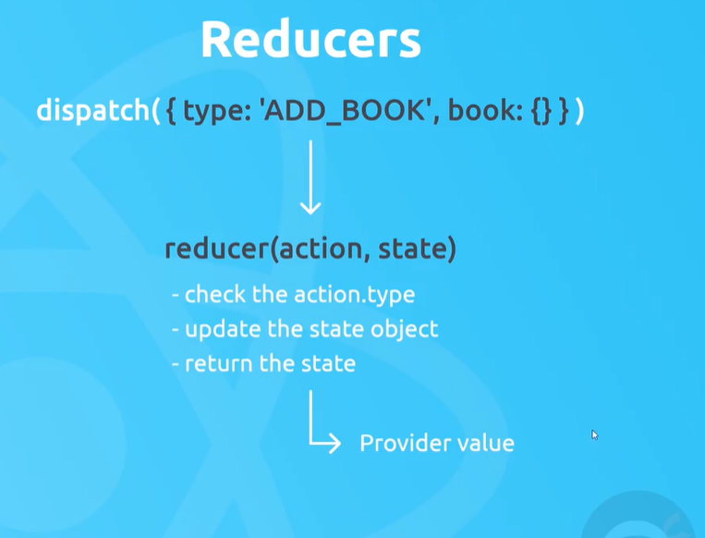

Example

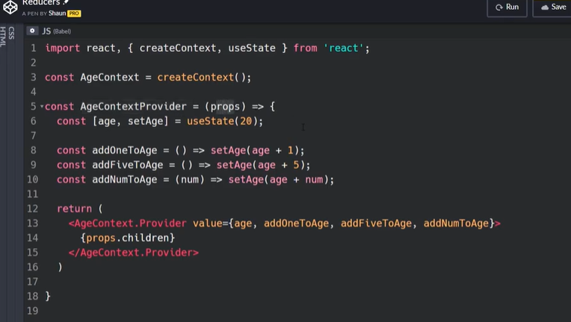

Using Reducers way

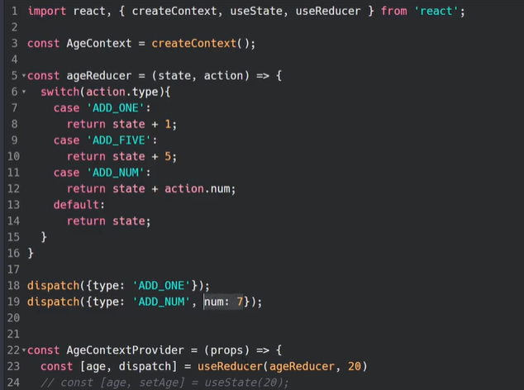

The logic is in the reducer 